

Lab 4: Create a virtual network

At the end of each lab, any resources you created in your account will be preserved. Some Azure resources, such as VM instances, may be automatically shut down, while other resources, such as storage services will be left running. Keep in mind that some Azure features cannot be stopped and can still incur charges (i.e. Azure Bastion). To minimize your costs, delete all resources and recreate them as needed to test your work during a session.

Reference: [AZ-900T0X-MICROSOFTAZUREFUNDAMENTALS](https://microsoftlearning.github.io/AZ-900T0x-MicrosoftAzureFundamentals)

# 04 - Create a virtual network

In this walkthrough, we will create a virtual network, deploy two virtual machines onto that virtual network and then configure them to allow one virtual machine to ping the other within that virtual network.

# Task 1: Create a virtual network (20 min)

In this task, we will create a virtual network.

1. Sign in to the Azure portal at [https://portal.azure.com](https://portal.azure.com/)
2. From the **All services** blade, search for and select **Virtual networks**, and then click **+ Add**.
3. On the **Create virtual network** blade, fill in the following (leave the defaults for everything else):

| Setting | Value |
| --- | --- |
| Name | **vnet1** |
| Address space | **Use the address space assigned in Blackboard (example: 10.1.0.0/16)** |
| Subscription | **Select your subscription** |
| Resource group | **myRGVNet** (create new) |
| Location | **(US) East US** |
| Subnet - Name | **default** |
| Subnet Address range | **Use an appropriate subnet address range (example: 10.1.0.0/24)** |

1. [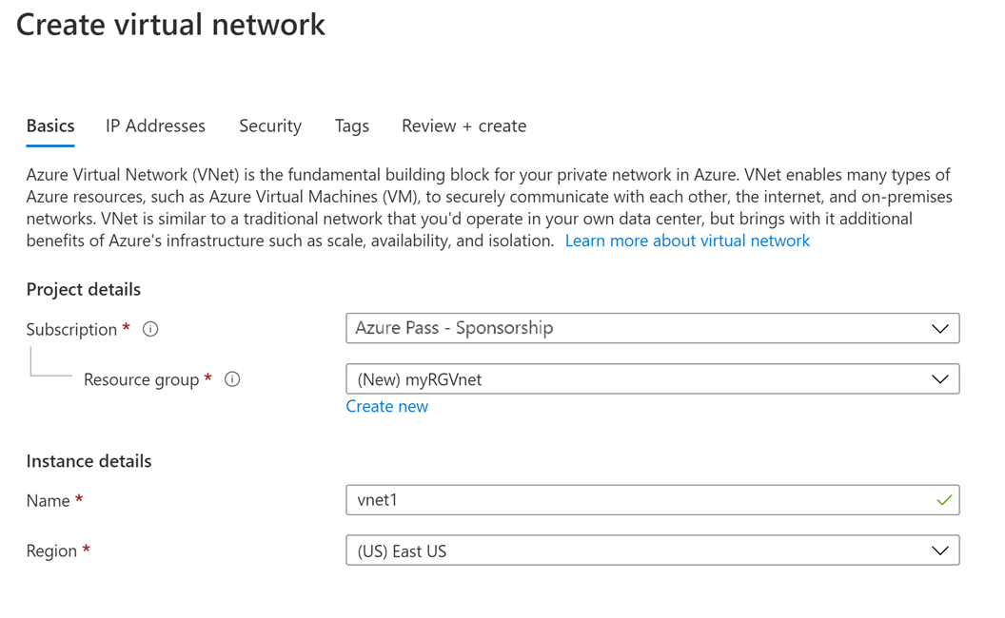](https://microsoftlearning.github.io/AZ-900T0x-MicrosoftAzureFundamentals/Instructions/images/0301a.png) [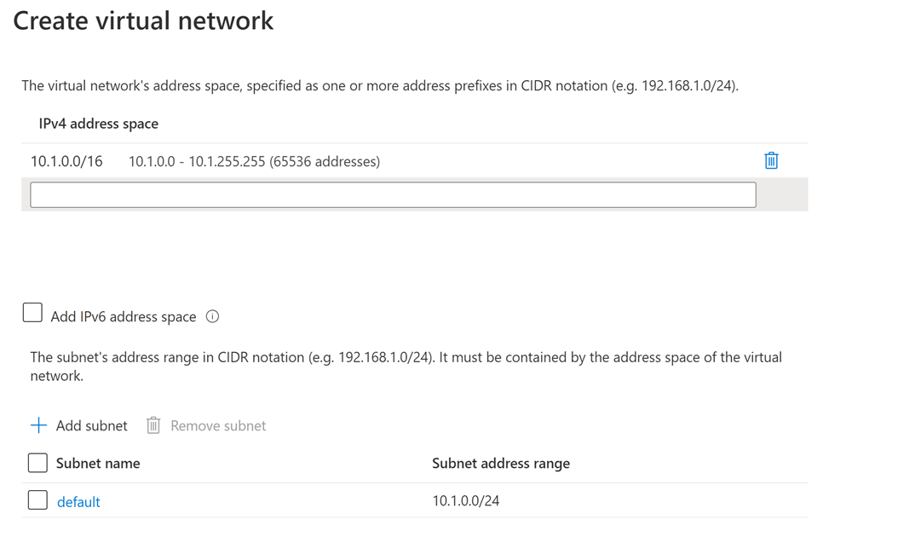](https://microsoftlearning.github.io/AZ-900T0x-MicrosoftAzureFundamentals/Instructions/images/0301b.png)
2. Click the **Review + create** button. Ensure the validation passes.
3. Click the **Create** button to deploy the virtual network.

**Note**: In your organization, how will you know which virtual networks and IP addressing you will need?

# Task 2: Create two virtual machines

In this task, we will create two virtual machines in the virtual network.

1. From the **All services** blade, search for **Virtual machines** and then click **+ Add**.
2. On the **Basics** tab, fill in the following information (leave the defaults for everything else):

| Setting | Value |
| --- | --- |
| Subscription | **Choose your subscription** |
| Resource group | **myRGVNet** |
| Virtual machine name | **vm1** |
| Region | **(US) East US** |
| Image | **Windows Server 2019 Datacenter** |
| Username | **azureuser** |
| Password | **Pa$$w0rd1234** |
| Public inbound ports | Select **Allow selected ports** |
| Selected inbound ports | **RDP (3389)** |
|  |  |

1. Select the **Networking** tab. Make sure the virtual machine is placed in the vnet1 virtual network. Review the default settings, but do not make any other changes.

| Setting | Value |
| --- | --- |
| Virtual network | **vnet1** |
|  |  |

1. Click **Review + create**. After the Validation passes, click **Create**. Deployment times can vary but it can generally take between three to six minutes to deploy.
2. Monitor your deployment, but continue on to the next step.
3. Create a second virtual machine by repeating steps **2 to 4** above. Make sure you use a different virtual machine name, that the virtual machine is within the same virtual network, and is using a new public IP address:

| Setting | Value |
| --- | --- |
| Resource group | **myRGVNet** |
| Virtual machine name | **vm2** |
| Virtual network | **vnet1** |
| Public IP | (new) **vm2-ip** |
|  |  |

1. Wait for both virtual machines to deploy.

# Task 3: Test the connection

In this task, we will allow ICMP connections and test whether the virtual machines can communicate (ping) each other.

1. From the **All resources** blade, search for **vm1**, open its **Overview** blade, and make sure its **Status** is **Running**. You may need to **Refresh** the page.
2. On the **Overview** blade, click the **Connect** button.

**Note**: The following directions tell you how to connect to your VM from a Windows computer.

1. On the **Connect to virtual machine** blade, keep the default options to connect by IP address over port 3389 and click **Download RDP File**.
2. Open the downloaded RDP file and click **Connect** when prompted.
3. In the **Windows Security** window, type the username **azureuser** and password **Pa$$w0rd1234** and then click **OK**.
4. You may receive a certificate warning during the sign-in process. Click **Yes** or to create the connection and connect to your deployed VM. You should connect successfully.
5. Open up a PowerShell command prompt on the virtual machine, by clicking the **Start** button, typing **PowerShell**, right clicking **Windows PowerShell** in the right-click menu, and clicking **Run as administrator**
6. Try to ping vm2 (make sure vm2 is running). You will receive an error, saying request timed out. The ping fails, because ping uses the **Internet Control Message Protocol (ICMP)**. By default, ICMP isn’t allowed through the Windows firewall.

CodeCopy

ping vm2

[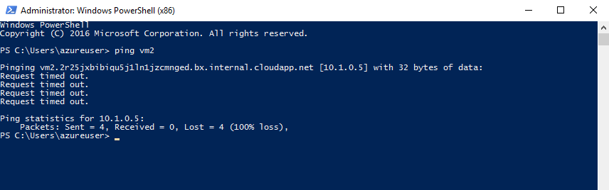](https://microsoftlearning.github.io/AZ-900T0x-MicrosoftAzureFundamentals/Instructions/images/0302.png)

**Note**: You will now open an RDP session to vm2 and allow incoming ICMP connections

1. Connect to **vm2** using RDP. You can follow steps **2 to 6**.
2. Open a **PowerShell** prompt and allow ICMP. This command allows ICMP inbound connections through the Windows firewall.

CodeCopy

New-NetFirewallRule –DisplayName “Allow ICMPv4-In” –Protocol ICMPv4

[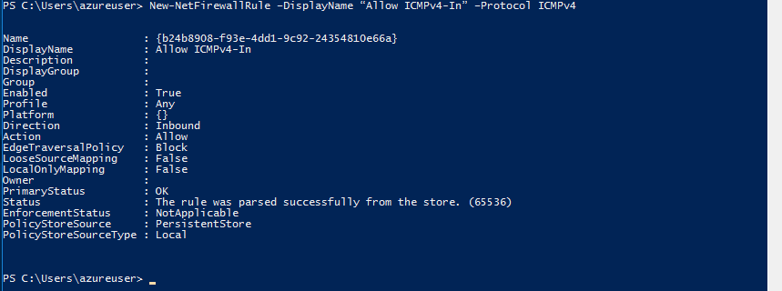](https://microsoftlearning.github.io/AZ-900T0x-MicrosoftAzureFundamentals/Instructions/images/0303.png)

**Note**: You will now switch to the RDP session to vm1 and try the ping again

1. Return to the RDP session to vm1 and try the ping again. You should now be successful.

CodeCopy

ping vm2

Congratulations! You have configured and deployed two virtual machines in a virtual network. You have also configured the Windows firewall so one of the virtual machines allows incoming ping requests.

**Note**: To avoid additional costs, you can remove all resources in the resource group. Search for resource groups, click your resource group, and then delete the resources within the resource group. **DO NOT DELETE YOUR RESOURCE GROUP.**

# Submission Requirements

Submit a screenshot with the following information:

Screenshot #1:

* Successful ping request from vm1 to vm2 using your assigned IP address space
* The Azure Portal with your login ID [requires another browser window]

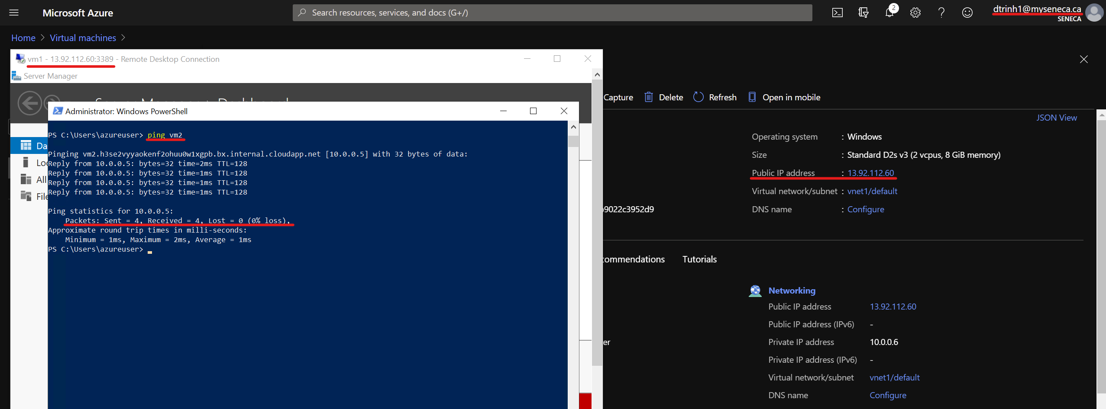

Screenshot #2:

* Successful deletion of resources within resource group. **DO NOT DELETE YOUR RESOURCE GROUP!**

